- Create a decision table for a Flipkart-style coupon validation system where a coupon is only valid if: (1) the user is logged in, (2) the cart value is above ₹500, and (3) the coupon has not expired. Show all possible combinations and the resulting action (accept/reject).
Ans=>

- Draw a state transition diagram for a Paytm login feature that locks the account after 3 failed password attempts and only unlocks after a successful OTP verification.
Ans=>

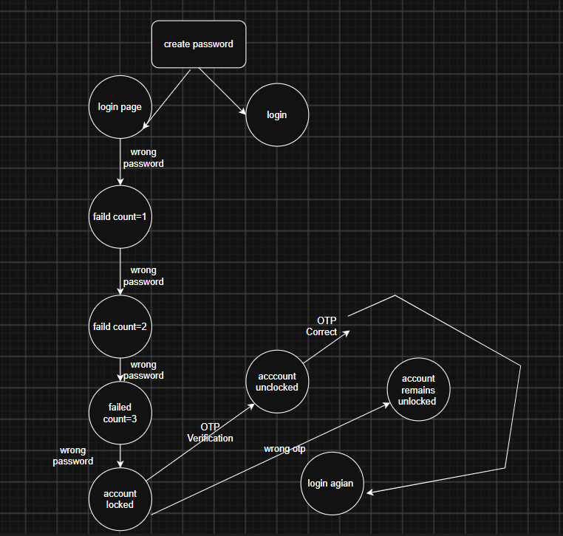

- Given the following use case: 'A Zomato user can place an order, cancel it before it is prepared, or track the order once prepared,' create a use case diagram and list at least 3 possible test scenarios based on it.
Ans=>
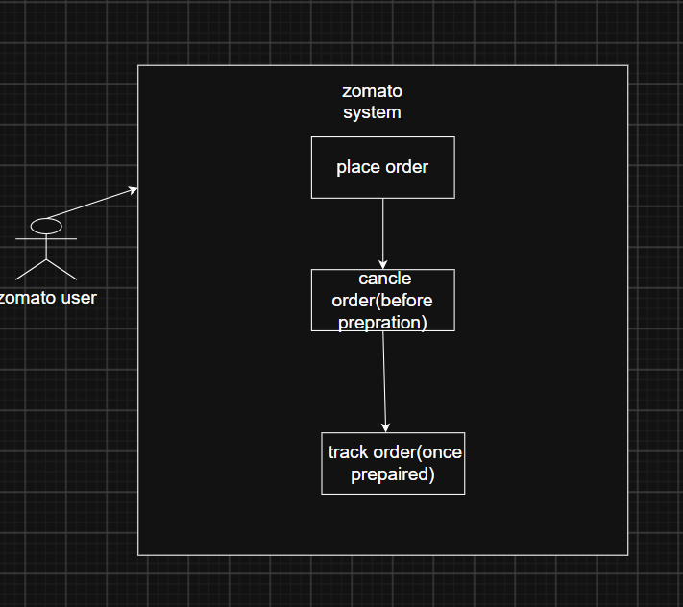

Test Scenarios=
- User selects food and places an order successfully.
- User tries to cancel the order before it is prepared.
- User tries to track the order once it is prepared

- Modify your decision table from Task 1 to include an additional rule: the coupon cannot be used more than twice by the same user. Update the table and explain how this new rule changes the possible outcomes.<br><br><em><strong>Hint:</strong> Add a column for 'Coupon Usage Count' and adjust the actions accordingly.</em>
Ans=>
